# **Code signature**

Table of Contents

Code signature 1

1. About code signature 2

1.1 public key and private key 2

1.2 Common case 2

1.3 Digest and signature 4

1.4 CA--certificate authority center and Digital certification 8

1.5 Communicate based on CA 9

1.6 Example for certification on Mac 10

1.7 Example for certification on website 11

2. Example certification for ios/mac developer 14

2.1 example 14

3. How to verify code signature 16

3.1 verifycation for Mac app 16

3.2 verifycation for Mac dylib 18

4. Encrypt and decrypt 20

5. How to signature code 21

6. Website for reference 22

# About code signature

## 1.1 public key and private key

**Public and private key:**

<http://www.ruanyifeng.com/blog/2013/06/rsa_algorithm_part_one.html>

<http://www.ruanyifeng.com/blog/2013/07/rsa_algorithm_part_two.html>

**Case example:**

Chinese version:

<http://www.blogjava.net/yxhxj2006/archive/2012/10/15/389547.html>

English version:

<http://www.youdzone.com/signature.html>

## 1.2 Common case

* **Bob: AliPay 777-xxxx-666**
* **Susan: AliPay 123-xxxx-666**
* **Doug: AliPay 456-xxxx-666**
* **Pat**







**Doug also has Bob’s public key, he wants to pretend to be Susan**



## 1.3 Digest and signature

basic concept about digest and signature



**Common case for using digest and signature**



**Vulnerability：**

**case for using digest and signature**





## 1.4 CA--certificate authority center and Digital certification

**Susan not sure the public key is from Bob or from Doug.**

**So Susan does not trust the public key.**

**And she want to get this from CA center, which certificate that the Bob’s public key**



## Communicate based on CA

**Now Susan can verify that the Bob’s public key did come from Bob**

**As it has been certificated by CA**



## Example for certification on Mac

**Go to keychain access**

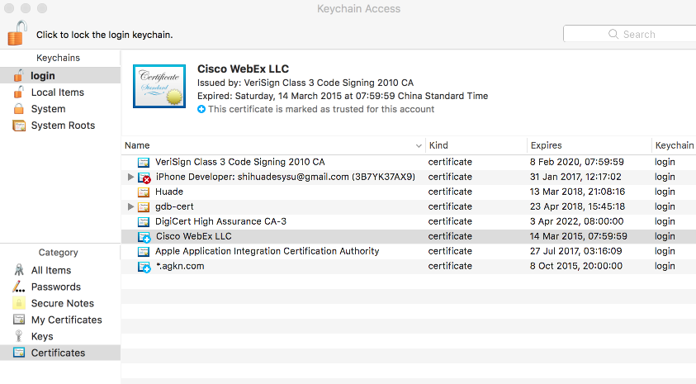

**Public key info for Cisco WebEx LLC**

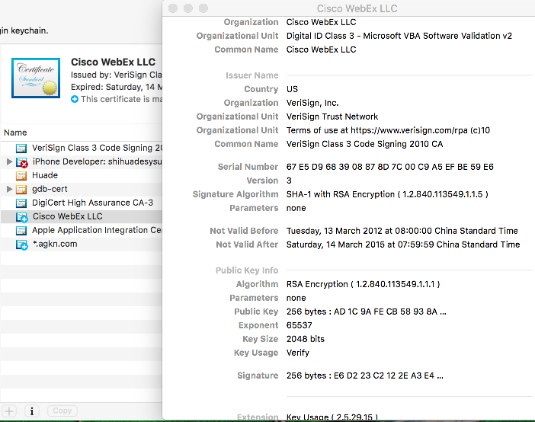

**Symantec’s CA for Cisco WebExLLC**

<https://www.symantec.com/about/legal/repository.jsp#rpa-ts>

## Example for certification on website

**Google website:**

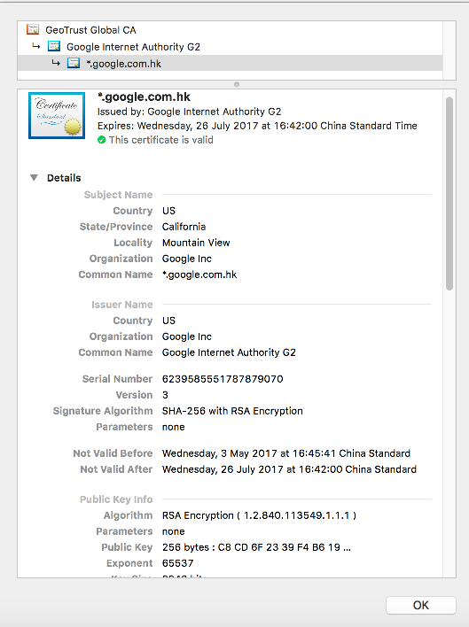

**Baidu website:**

**Baidu’s CA:** <https://www.globalsign.com/en/repository/>

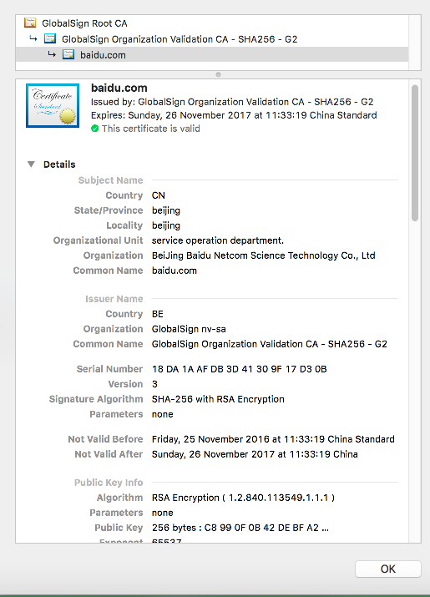

**ICBC net bank**

<https://mybank.icbc.com.cn/icbc/newperbank/perbank3/frame/frame_index.jsp>

**CA by Symantec:**

<https://www.symantec.com/about/legal/repository.jsp#stn-cps>

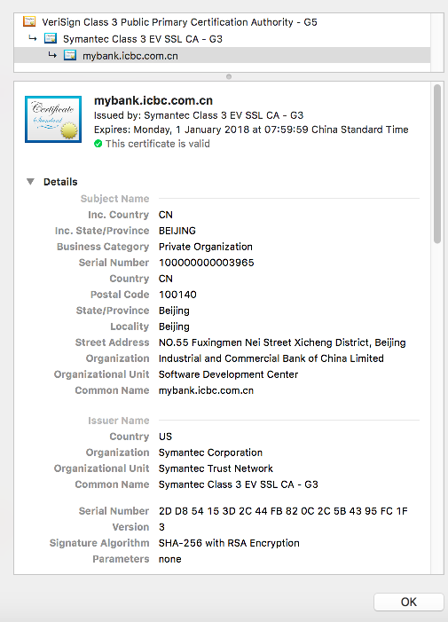

# Example certification for ios/mac developer

## 2.1 example

**Application Code Signing**

<https://developer.apple.com/library/content/documentation/General/Conceptual/DevPedia-CocoaCore/AppSigning.html>



**Example in Chinese:**

<http://foggry.com/blog/2014/10/16/ios-code-signing-xue-xi-bi-ji/>

**Code signature for mac**

<http://osxdaily.com/2016/03/14/verify-code-sign-apps-mac-os-x/>



**Example for iOS Code Signing & Provisioning in a Nutshell**

<https://medium.com/ios-os-x-development/ios-code-signing-provisioning-in-a-nutshell-d5b247760bef>



# How to verify code signature

## 3.1 verifycation for Mac app

**Example website:**

<http://osxdaily.com/2016/03/14/verify-code-sign-apps-mac-os-x/>

**Command:**

codesign -dv --verbose=4 /Path/To/Application.app

**Verification for Spark app:**

codesign -dv --verbose=4 /Applications/"Cisco Spark.app"

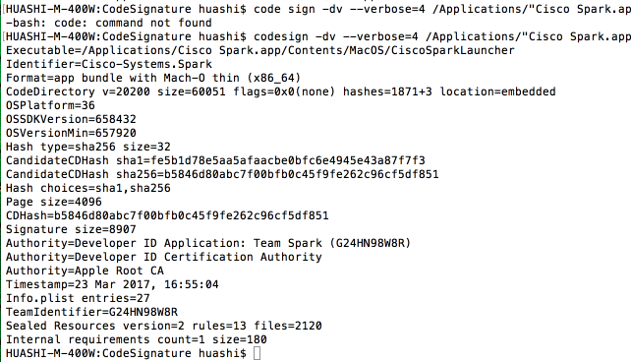

**Verification for 爱奇艺. app:**

 codesign -dv --verbose=4 /Applications/"爱奇艺.app"

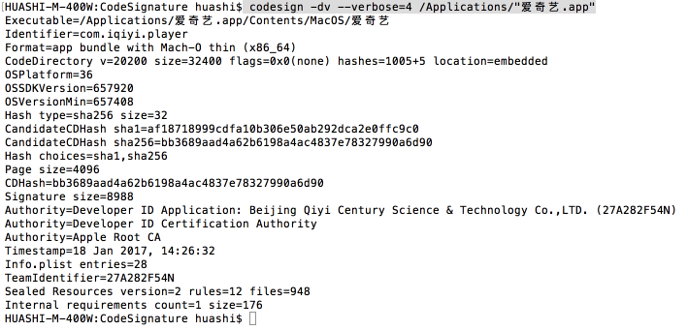

**Verification for FFMPEG:**

codesign -dv --verbose=4 /Applications/ffmpeg

ffmpeg is clone from:

git://source.ffmpeg.org/ffmpeg.git

and make install only without code signature



## 3.2 verifycation for Mac dylib

**Example for openh264 dylib code signature verification**

**Example for those code-signed packages from openh264 office website**

Openh264 release package:

<https://github.com/cisco/openh264/releases>

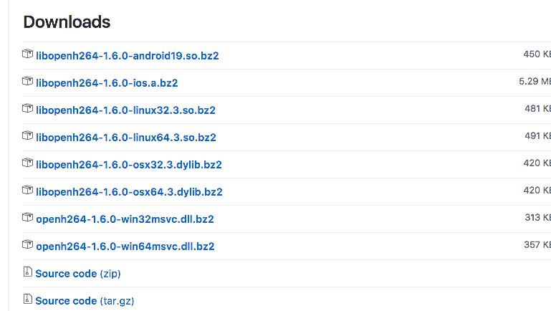

take libopenh264-1.6.0-osx64.3.dylib.bz2 for example:

codesign -dv --verbose=4 ~/Desktop/openh264-mac-release/libopenh264-1.6.0-osx64.3.dylib

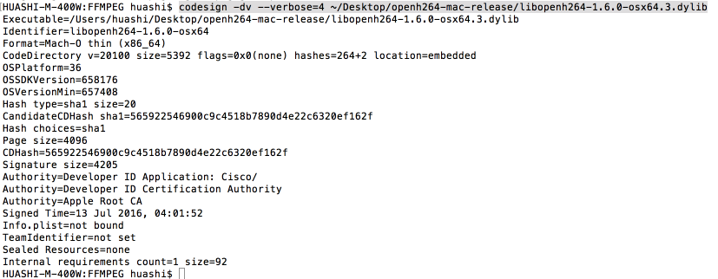

**Example for make only without code signature**

**Clone openh264 from openh264 office website**

<https://github.com/cisco/openh264.git>

**and build dylib with command:**

make

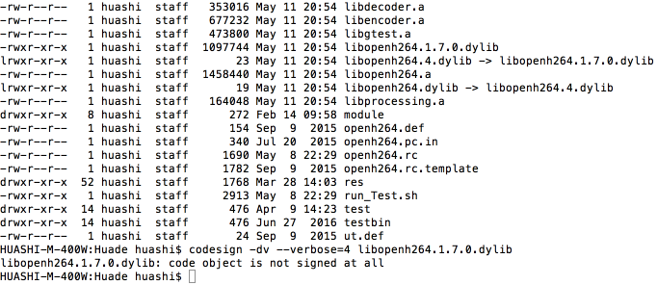

# Encrypt and decrypt

**For how to encrypt/decrypt data/files/packages, please refer to:**

<https://gist.github.com/colinstein/de1755d2d7fbe27a0f1e>

# How to signature code

**For how to signature code on different os, like ios/android/windows/mac/linux etc.**

**You can get tool via google etc.**

# Website for reference

**Mac**

<https://www.symantec.com/content/en/us/about/media/repository/root-certificates.pdf>

<http://osxdaily.com/2016/03/14/verify-code-sign-apps-mac-os-x/>

<https://www.digicert.com/code-signing/mac-os-codesign-tool.htm>

<http://osxdaily.com/2016/03/14/verify-code-sign-apps-mac-os-x/>

<https://developer.apple.com/library/content/documentation/Security/Conceptual/CodeSigningGuide/Procedures/Procedures.html>

<https://developer.apple.com/library/content/technotes/tn2206/_index.html>

<https://support.apple.com/en-us/HT202369>

<http://blog.leanote.com/post/yinhaide/MAC%E7%8E%AF%E5%A2%83%E4%B8%8B%E7%94%9F%E6%88%90Apple%E8%AF%81%E4%B9%A6%E6%95%99%E7%A8%8B>

**widows:**

<https://msdn.microsoft.com/en-us/library/ms537362(v=vs.85).aspx>

<https://msdn.microsoft.com/en-us/library/ms537361(v=vs.85).aspx>

**ios:**

<http://foggry.com/blog/2014/10/16/ios-code-signing-xue-xi-bi-ji/>